# **Movie Trailer Program Guide**

This project is intended to be used within the Cassidy Lab (The Royal’s Institute of Mental Health Research, affiliated with uOttawa) for experiments conducted to study users’ interpretations of Movie Trailers.

This Python program was originally created by Dustin Doucette, a 4th year undergraduate Computer Science student at Carleton University.

This document will provide a user-friendly guide on how to properly use the Movie Trailer program. There is also a word-based explanation in the README.md file within the project. If this guide is to be given to a user once the program is up and running, you can tell them to start at step 3.

## Step 1) Open a command prompt (cmd.exe) and traverse to the directory which contains the downloaded program (e.g. “C:\MovieTrailerProgram\”).

Step 2) Execute the command “python .\Program.py”.

**Note:** The first startup after placing new trailers in the movie trailer program will take longer to start the first GUI. This is because the program is taking screenshots of individual frames from the trailers for later use in the program.

Step 3) Click the “**Start**” button in the main menu to begin the experiment.

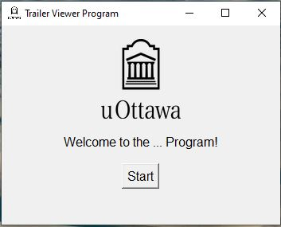

Step 4) Enter your user ID in the white entry box, then press “**Begin Testing**”.

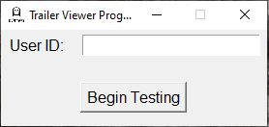

Step 5) Select “**Start Trailer**” to begin viewing the next trailer in the lineup, the title of the movie will be displayed on the screen.

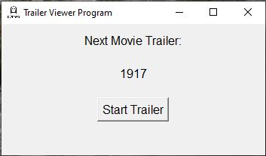

Step 6) After the movie trailer has finished, close the video application and press “**Continue**” on the program window.

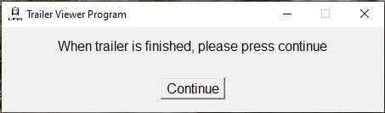

Step 7) Select all the relevant boxes (if the movie trailer had funny, scary and/or sexy content), then press “**Next**”.

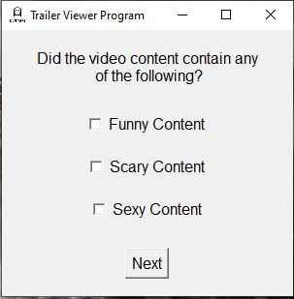

Step 8) Adjust the sliders to reflect your ratings (scale of 1-10), then press “**Next**”. Only the sliders related to the content you selected in step 7 will be available to modify.

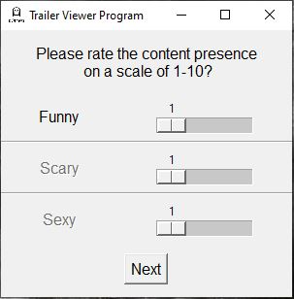

Step 9) Select all of the relevant frame sections which contain the specified content.

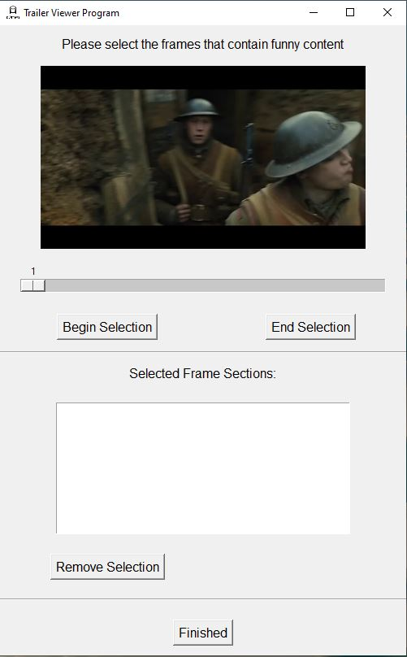

**E.g.** If you want to select a scene from frame 10 to 20, first drag the slider to frame 10 and select “**Begin Selection**”. Then drag the slider to frame 20 and select “**End Selection**”. This will add that frame selection to the “Selected Frame Sections” box. If you made a mistake, simply click the selection within the “Selected Frame Sections” (the selection will highlight) and press “**Remove Selection**”. Once all frame sections are selected, press “**Finished**”.

**Note:** You will be given a new window for each box you selected in step 7. There will also be a separate window for “Important” content.

Step 10) If there are more movie trailers to be reviewed, the name of the next movie trailer will be displayed. Press “**Start Trailer**” (This will bring you back to step 5, but with a new trailer).

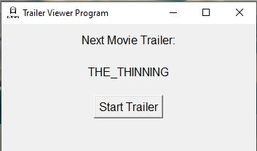

Step 10) If there are no more movie trailers to be reviewed, a thank you message is displayed, and you can now close the window using the escape button (terminating the program).

